BIRLA INSTITUTE OF TECHNOLOGY & SCIENCE, PILANI (RAJASTHAN)
CS G532 High Performance Heterogeneous Computing
Lab#2

Note: Please use programs under Code directory supplied with this sheet. Do not copy from this sheet.

The lab has the following objectives:
Practice programs for MPI.

- MPI communication primitives

Basic functions to send and receive data in MPI are MPI_Send and MPI_Recv. Consider the following program given in mpi_hello.c

- int main(void) {
- char greeting[MAX_STRING]; /* String storing message */
- int comm_sz; /* Number of processes */
- int my_rank; /* My process rank */

- /* Start up MPI */
- MPI_Init(NULL, NULL);

- /* Get the number of processes */
- MPI_Comm_size(MPI_COMM_WORLD, &comm_sz);

- /* Get my rank among all the processes */
- MPI_Comm_rank(MPI_COMM_WORLD, &my_rank);

- if (my_rank != 0) {
- /* Create message */
- sprintf(greeting, "Greetings from process %d of %d!",
- my_rank, comm_sz);
- /* Send message to process 0 */
- MPI_Send(greeting, strlen(greeting)+1, MPI_CHAR, 0, 0,
- MPI_COMM_WORLD);
- } else {
- /* Print my message */
- printf("Greetings from process %d of %d!\n", my_rank, comm_sz);
- for (int q = 1; q < comm_sz; q++) {
- /* Receive message from process q */
- MPI_Recv(greeting, MAX_STRING, MPI_CHAR, q,
- 0, MPI_COMM_WORLD, MPI_STATUS_IGNORE);
- /* Print message from process q */
- printf("%s\n", greeting);
- }
- }

- /* Shut down MPI */
- MPI_Finalize();

- return 0;
- } /* main */

In the above program, all processes send a message to rank 0 process. Rank 0 processes receives all and prints them.
Q?
- Compile the above program using mpicc mpi_hello.c Run mpiexec -n 4 a.out
- In the current program, rank 0 process is getting strings sequentially in the order of process rank. Modify the above program so that rank 0 process can receive from any process but comm_sz times. How can rank 0 process who is sending message? [Hint: use MPI_Status variable instead of MPI_STATUS_IGNORE]
- Modify the above program for: All non-root processes send two messages with tags “A” and “B”. Rank 0 should receive tag ‘B’ first and then tag ‘A’ messages.
- Change the above program such that every process sends a message to its right neighbour in a ring network.
- Change the above program such that a process sends a message to a process with rank equal to (own_rank + (comm_sz/2^itr_no)). There is log(comm_sz) iterations. Not all processes are active in the beginning iterations.

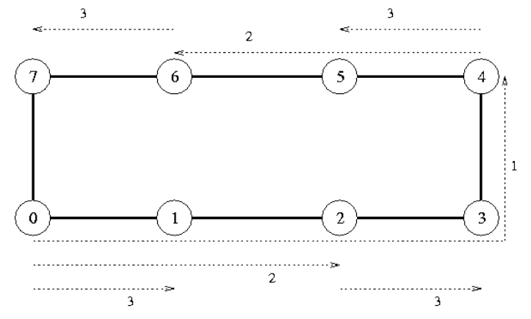

- Collective computation
The following program evaluates an integral for given intervals on function f.

- #include<mpi.h>
- #include<stdio.h>

- double func(double x) {
- return (double)x * x;
- }

- double Trap(double a, double b, int n, double h) {
- double area = (func(a) + func(b)) / 2.0;
- for (int i = 1; i <= n - 1; ++i) {
- double x = a + i * h;
- area += func(x);
- }
- area *= h;
- return area;
- }

- int main() {
- int my_rank, comm_sz, n = 1024, local_n;
- double a = 0.0, b = 3.0, h, local_a, local_b;
- double local_int, total_int;
- int source;
- MPI_Init(NULL, NULL);
- MPI_Comm_rank(MPI_COMM_WORLD, &my_rank);
- MPI_Comm_size(MPI_COMM_WORLD, &comm_sz);
- h = (b - a) / n; /* h is the same for all processes */
- local_n = n / comm_sz; /* So is the number of trapezoids */
- local_a = a + my_rank * local_n * h;
- local_b = local_a + local_n * h;
- local_int = Trap(local_a, local_b, local_n, h);
- if (my_rank != 0) {

- MPI_Send(&local_int, 1, MPI_DOUBLE, 0, 0, MPI_COMM_WORLD);

- }
- else {

- total_int = local_int;
- for (source = 1; source < comm_sz; source++) {
- MPI_Recv(&local_int, 1, MPI_DOUBLE, source, 0, MPI_COMM_WORLD,

- MPI_STATUS_IGNORE);

- total_int += local_int;

- }
- }
- if (my_rank == 0) {

- printf("With n = %d trapezoids, our estimate\n", n);
- printf("of the integral from %f to %f = %.15e\n",
- a, b, total_int);

- }
- MPI_Finalize();
- return 0;
- }

Q?
- Compile the program with `mpicc point2point.c`. Run mpiexec -n 4 a.out . Add MPI_Wtime at line no 24 and 54 and print the time taken. Measure time with respect to increasing number of processes 1 2 3 4 …. Check the speedup achieved. Compute efficiency as well.
- Change the above program so that variables a, b and n are dynamically read from user in rank 0 and shared with other processes. Can we read from standard input in non-root processes?
- Can line nos 39-44 be replaced with MPI_Reduce? Change your program accordingly? Is there any difference in execution time n=1 2 3 4 5 6 ?
- What should we do if all processes need to know the total integral?

- Collective Communication Routine
This is a program to distribute rows of an array to separate processes.

- #include<mpi.h>
- #include<stdio.h>

- #define SIZE 4

- int main(int argc, char* argv[]) {
- int numtasks, rank, sendcount, recvcount, source;
- float sendbuf[SIZE][SIZE] = {
- {1.0, 2.0, 3.0, 4.0},
- {5.0, 6.0, 7.0, 8.0},
- {9.0, 10.0, 11.0, 12.0},
- {13.0, 14.0, 15.0, 16.0}
- };
- float recvbuf[SIZE];
- MPI_Init(&argc, &argv);
- MPI_Comm_rank(MPI_COMM_WORLD, &rank);
- MPI_Comm_size(MPI_COMM_WORLD, &numtasks);
- if (numtasks == SIZE) {
- // define source task and elements to send/receive, then perform collective scatter
- source = 1;
- sendcount = SIZE;
- recvcount = SIZE;
- MPI_Scatter(sendbuf, sendcount, MPI_FLOAT, recvbuf, recvcount, MPI_FLOAT, source, MPI_COMM_WORLD);
- printf("rank= %d Results: %f %f %f %f\n", rank, recvbuf[0], recvbuf[1], recvbuf[2], recvbuf[3]);
- }
- else
- printf("Must specify %d processors. Terminating.\n", SIZE);
- MPI_Finalize();
- }

Q?
- Compile and run the program with mpirun -np 4 ./a.out or mpiexec -n 4 a.out. Why was Scatter used here instead of Bcast?
- Suppose we need to send first two rows to P0 and next two rows to P1. Modify above program in this regard.
- Suppose SIZE is not equal to number of processes. Says number of processes is 3. Use MPI_Scatterv. Modify the given program.

Consider the program given mpi_mat_vect_mult.c. This program implements Matrix Vector implementation using MPI. Rank 0 takes input from user/random and distributed to other processes.

Q?
- This program shows usage of broadcast, scatter, gather and allgather routines. Why do we need to call MPI_Allgather in line 434? Modify the program so that every process will have all elements of x? Measure time taken for original and modified program.

Consider program given in mpi_odd_even.c file. This is the implementation of odd-even transposition sort.

Q?
- This program uses MPI_Sendrecv leaving the scheduling of send and receive in multiple processes to MPI runtime. Replace MPI_Sendrecv with MPI_Send and MPI_Recv functions. Does it lead to deadlock?

- Derived Data type

Consider the program given in mpi_trap4.c This program instead of broadcasting a,b and n separately to all processes, creates a new datatype and broadcasts all together.

Q?
- Compile and run the program.
- Change the program so that new datatype includes not just a, b, and n but also source and destination ranks and message “hello”.

Process Topology

- #include<mpi.h>
- #include<stdio.h>

- int main(int argc, char* argv[]) {
- int rank, size;
- MPI_Comm comm;
- int dim[2], period[2], reorder;
- int coord[2], id;

- MPI_Init(&argc, &argv);
- MPI_Comm_rank(MPI_COMM_WORLD, &rank);
- MPI_Comm_size(MPI_COMM_WORLD, &size);

- dim[0] = 4; dim[1] = 3;
- period[0] = 1; period[1] = 0;
- reorder = 1;
- MPI_Cart_create(MPI_COMM_WORLD, 2, dim, period, reorder, &comm);
- if (rank == 5) {
- MPI_Cart_coords(comm, rank, 2, coord);
- printf("Rank %d coordinates are %d %d\n", rank, coord[0], coord[1]);fflush(stdout);
- }
- if (rank == 0) {
- coord[0] = 3; coord[1] = 1;
- MPI_Cart_rank(comm, coord, &id);
- printf("The processor at position (%d, %d) has rank %d\n", coord[0], coord[1], id);fflush(stdout);
- }
- MPI_Finalize();
- return 0;
- }
Q?
- This is a program which generates a virtual topology in the form of a 3x4 array with wrap around (a 2D torus). Run the above program with `mpirun -np 12 ./a.out`.
- Can you change the dimensions of the topology?

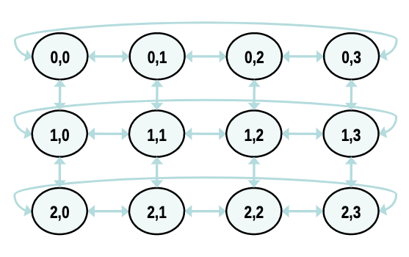Figure 1: Source: codingame.com
End of lab

